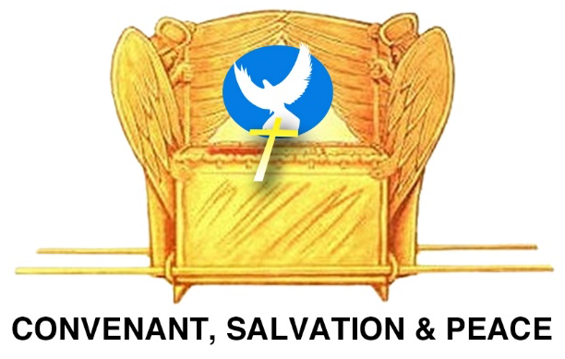
Throne of Grace Ministries

4
Passport
Photos
Needed
For Visa
Senior Citizens Journey to Mother Land
Volunteer Mission Application Form

The __________________________ Mission; Date ________________, 2022

Total Cost $ 3, 925.00_

Non-refundable deposit of $100.00 is due 10 days after application is received.

Please complete and return within ten days!

Last Name _________________ First Name __________________ Middle Initial _____

Maiden Name (if applicable) ______________________ SS# ______________________

Date of Birth ________ / __________ / _________

Are you a senior citizen or Volunteer: Yes or No

Mailing Address (where do you want your correspondence sent)

Phone #s: Home ____________________________ Work ________________________

Fax # ________________________________ Pager # ___________________________

Email Address ___________________________________________________________

Marital Status __________________ Your Occupation ___________________________

If married, name of spouse __________________________________________________

Your Passport # __________________________ Place Issued _____________________

Date of Passport Expiration _______/ ______/ ________

If you do not have a passport, you MUST apply for one as soon as possible in order to possess a valid passport in time for the trip and trip preparation. Do not hesitate to take action NOW to get one. Supply us with this information as soon as you acquire it. Everyone MUST submit a photo-quality copy of his or her passport. Visa may be necessary for some countries.

Your area(s) of interest as it pertains to this trip: _________________________________
Musical Support, Bible Study Leader, Prayer & Devotion Leader, Group Leader, Medical, Construction, Children, Education, Counseling, Logistics and etc.

Your Home Church ______________________________ Pastor ___________________

Church Address __________________________________________________________

Phone # ____________________________ Email _______________________________
Church Recommendation: The___________________________ (name of church)
Wholeheartedly recommends the applicant to the Global Mission Team of Throne of Grace Ministries, as sound in his/her faith and spiritually equipped to serve on this volunteer project, for the KING.

Signature of Pastor ____________________________ Date __________/ ________/ ___

MISSION TEAM Volunteers Wear A Special Mission T-Shirt While Traveling. What Size Will You Require?
(Please circle) M L X-L XX-L

Please list your interests and area of giftedness: _________________________________

HEALTH HISTORY

Name of Personal Physician ______________________________ Phone ____________

Your Blood Type ________ Can you donate blood? _____________________________

Please list any current problem: _____________________________________________

Have you ever had, or have you now, any of the following? If yes, please explain on a separate sheet of paper: (check those which apply)

- Frequent and / or severe headaches _________
- Dizziness or fainting _________
- Convulsions _________
- Nervous Breakdown _________
- Mental Problems _________
- Asthma _________
- Allergies _________
- Epilepsy _________
- Hearing Difficulties _________
- Heart Problems _________
- High/Low Blood Pressure _________
- Breathing Problems _________
- Digestion Problems _________
- Back or neck Problems _________
- Others? _________
Do you have any allergies? If so, please list: _________________________

Please list any current medications _________________________________

Have you had the following vaccinations? When?
- Yellow Fewer __________
- Full Hepatitis B Immunization series __________
- Tetanus booster in the 5-10 years __________
- Hepatitis A vaccine __________
- Full Polio vaccination series __________
- Measles, Mumps, Rubella, & Chicken Pox vaccines __________
HEALTH INSURANCE

Name of Insurance Company ________________________________________________

Address ________________________________________________________________

Phone # _________________________________ Policy # ________________________

This policy is issued in the name of ___________________________________________

If Group Policy, Please List Employer ________________________________________

Employer Phone # ________________________________________________________

Please be sure to attach a legible copy of your health insurance card (from and back) and verify the information submitted above.
EMERGENCY NUMBERS

Name ________________________________________ Relationship to you __________

Address ________________________________________________________________

Phone#: Day ____________________________ Night ___________________________

Name ________________________________________ Relationship to you __________

Address ________________________________________________________________

Phone#: Day ____________________________ Night ___________________________

Throne of Grace Ministries

Personal Testimony

Please give a brief testimony of your Christian experience and how God has worked in your life since (Use Acts 22:3-21 as a guide).

Your story from your native country and your experience in the USA

Name: ___________________________________ Date _______________

__________________________________________________________________________________________________________________________
__________________________________________________________________________________________________________________________
__________________________________________________________________________________________________________________________
__________________________________________________________________________________________________________________________
__________________________________________________________________________________________________________________________
__________________________________________________________________________________________________________________________
__________________________________________________________________________________________________________________________
__________________________________________________________________________________________________________________________
__________________________________________________________________________________________________________________________
__________________________________________________________________________________________________________________________
__________________________________________________________________________________________________________________________
__________________________________________________________________________________________________________________________
__________________________________________________________________________________________________________________________
__________________________________________________________________________________________________________________________
__________________________________________________________________________________________________________________________
_______________________________________________________________________________________________________________________________________________________________________________________
__________________________________________________________________________________________________________________________
__________________________________________________________________________________________________________________________
__________________________________________________________________________________________________________________________
_____________________________________________________________
__________________________________________________________________________________________________________________________
__________________________________________________________________________________________________________________________
__________________________________________________________________________________________________________________________
__________________________________________________________________________________________________________________________
_____________________________________________________________

